Evolt Combines Tech and Wellness to Arm Aussies with Knowledge of Their Real Body Composition
With the Fitness Show making its highly anticipated return to Brisbane on 13th – 14th July, event attendees can expect the coming together of some of the biggest fitness, health and wellness celebrities and brands in Australia, promoting the latest in fitness education, technology, health foods, sports nutrition, group fitness and fitness apparel.

By 2025 it’s estimated that the health and wellbeing monitoring segment could be worth up to $1.6 trillion USD, and helping to lead the charge at the Fitness Show in this space is Evolt. The company has developed an end-to end solution that tracks detailed changes in the quality of activity, body composition and nutrition as well as sophisticated data analytics for member body composition changes.

Evolt is at the forefront of technology and uses an evidence-based approach to its development and practical use. They have their own research and development team consisting of highly qualified professionals in the field of exercise science, body composition and nutrition.
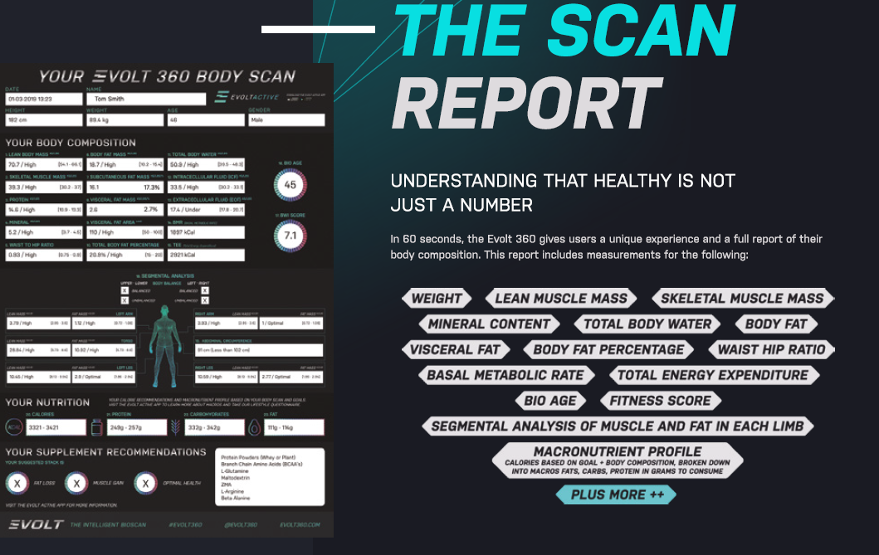
After the success of Sydney Fitness Show, back in April, whereby the team scanned over 5000 consumers over the three-day event and sold 30+ Evolt 360 body scanners to gyms, supplement stores, personal trainers etc. they are excited to take their wellness tech to Brisbane. With the launch of their new app in June, the Brisbane show makes for the perfect platform to promote themselves and cement them as leaders within their field in the fitness industry.
We also have available for further comment - Ed Zouroudis Evolt CEO and Kelly Weideman Business Development Manager

